AJAX = **A**synchronous **J**avaScript **A**nd **X**ML.

AJAX is not a programming language.

AJAX just uses a combination of:

* A browser built-in XMLHttpRequest object (to request data from a web server)

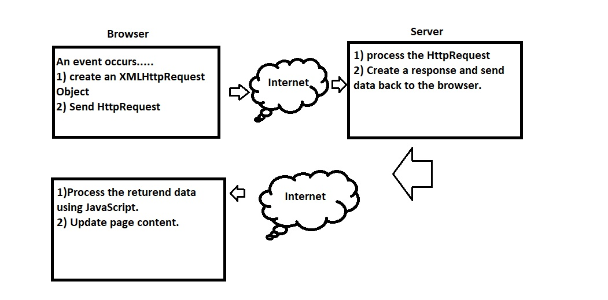

The XMLHttpRequest object is used to exchange data with a server.

To send a request to a server, we use the open() and send() methods of a XMLHttpRequest object:

Open(method,url,async)

**Server response**:

4 stage:-> use onreadystatechange (**onreadystatechange** stores the function that will process the response from the server.)property:

1. Connection
2. Server process
3. Response for process.
4. Ready to send the response.

**Status:**

**Check ok or error -> 200 is ok, 404 error.**